Mental Health Awareness and Resource Sharing for Parents / Guardians
(Funded by an Ministry of Education “Parents Reaching Out” Grant)
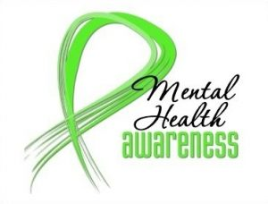
OLM School Council is hosting a
Mental Health Awareness and Resource Sharing
at Our Lady of Mercy Catholic School
Tuesday, January 9th from 5:30 pm to 7:00 pm

Presentations will include:
- “The Principled Child: How to do it…. I think” by Dr. Dean Tripp. Queen’s University
- Algonquin and Lakeshore CDSB Mental Health Lead, Alex Weedmark
- Contact / resource personnel from local Community Agencies (e.g., Counselling Services of Belleville & District, North Hastings Community Integration, Addictions & Mental Health Services HPE, etc…)

Pizza will be provided, as well as beverages and fresh fruit/veggies for all attending. Please indicate below the number of pizza slices and beverages requested by your family for this event. Thank you.

PLEASE RETURN THIS PORTION by December 21st
We also plan to make childcare available to allow more people to attend.
Please indicate if you would like childcare _______ Yes _______ No
I will be bringing ________ child(ren) who will require childcare.

My family______________________________ (indicate family surname) wishes to pre-order the following for OLM Mental Health Awareness and Resource Sharing Night, JANUARY 9th 2018
There will be _______ family members attending.
- Juice boxes (apple) _______ (orange) _______
- Water, (non-bottled) – please consider bringing you own water bottle to fill from our Hydration Station.
- Coffee _______
- Slices of pepperoni & cheese pizza _______________
Fruits and veggies will also be available.

